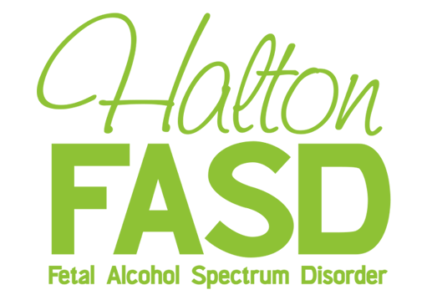
Halton FASD Assessment & Diagnostic Clinic:
Referral Criteria and Process

Referral Criteria:

- Age 2* to 17 years, 11 months of age
- Confirmed report of prenatal alcohol exposure from a reliable source
- Living in Halton Region
- Presenting with delays in development (e.g., language, motor, academic) or difficulties in social, emotional, adaptive, cognitive and/or behavioral, functioning (e.g., regulation of attention, impulse control, activity level).

- Assessments will also be considered for individuals previously identified as ‘At risk for Neurodevelopmental Disorder and/or Fetal Alcohol Spectrum Disorder’ and circumstances have changed such that assessment is now deemed appropriate (e.g., child is older now and testable).

Referral Process:
- Referral Agency obtains consent from the client’s legal guardian to obtain and disclose information pertaining to the client from/to the Halton FASD Clinic (See community partners consent form).

- Referring agency completes the referral form and submits to Clinic Coordinator.
Referral forms can be accessed on the Halton FASD website (www.haltonfasd.ca).
Please Fax (905-681-7477) or drop off forms to ROCK (471 Pearl Street, Burlington) Attention: FASD Clinic Coordinator. Please DO NOT send confidential referral information through email.

- Referrals will be reviewed by the Clinic Coordinator on a regular basis. Clinic Coordinator will decide whether further review is needed by the Diagnostic and Assessment Clinical Team in order to determine next steps. When needed Clinical Team reviews referrals once a month (on clinic day). The Clinic Coordinator will communicate the results of the referral review to the referral source and will make suggestions on accessing other services where appropriate. If accepted for assessment by the HALTON FASD Clinic the referral source will be given some idea of the wait for assessment or a clinic day appointment.

Facial Features are felt to be more accurately assessed by age 2. Children <2 years of age should be referred to pediatrician to determine whether they meet criteria for the ‘at risk’ category.

